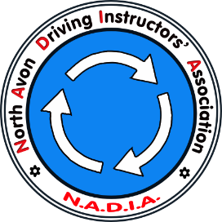
North Avon Driving Instructors’ Association

Membership Application Form

I wish to join North Avon Driving Instructors Association.
I agree to abide by the rules of the association and its code of conduct.
I enclose £25 in respect of my annual membership fee: Chq Cash BACS

Signature: __________________________________ Date:__________________

Name: ….........................................................................................................

Trading Name: ….........................................................................................................

Address: ….........................................................................................................

…...............................................................................................................................

…......................................................................Postcode:.......................................

Telephone: Home:................................................................................................

Mobile:...............................................................................................

Email (CAPS):...................................................................................................................

I am a fully qualified A.D.I. □ I am a trainee / P.D.I. □

Other: (Please give details)..................................................................................................

…...........................................................................................................................................
What kind of training do you usually undertake?

…...........................................................................................................................................

Do you wish to be considered to assist with NADIA’s Under 17 Driver Training? □
Please return to: Jerry Price  (NADIA Secretary)  11 Cranham, Yate  Bristol  BS37 4JT | Details for Bank Transfer:  NADIA  Sort code: 30-12-04  Account: 01192390  Please reference as "SUBS" followed by your name.

